**Objective Question**

**1. What is the total no. of tables present in the data?**

**Answer:**  The number of Tables present in the data are 2.

**Tables:**

* Raw Data

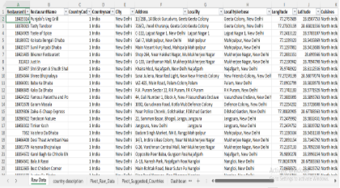

* country description

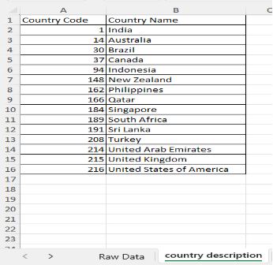

**2. What is the total number of attributes present in the data?**

**Answer:** 1. 24 attributes in the Raw Data table.

2. 2 attributes in country description table.

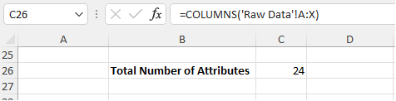

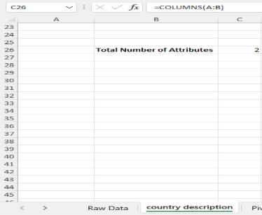

### **3. How many categorical columns are there in the data?**

**Answer:** 12 categorical columns  
 (These contain text or limited distinct values):

* Restaurant Name
* City
* Country name
* Address
* Locality
* LocalityVerbose
* Cuisines
* Currency
* Has_Table_booking
* Has_Online_delivery
* Is_delivering_now
* Switch_to_order_menu

Total Categorical Columns = **12**

**4. The data consists of some inconsistent and missing values so ensure that the data used for further analysis is cleaned.**

**Answer:** Select all data → Press Ctrl + G → Click "Special" → Select "Blanks”. (for highlight)

For counting the no. of missing data (=COUNTBLANK ('Raw Data’! A1:U9552))

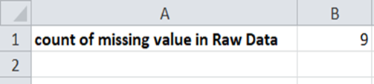

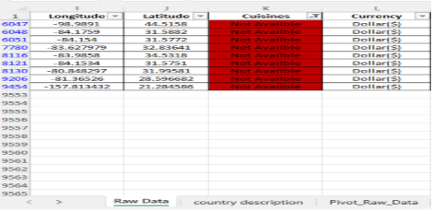

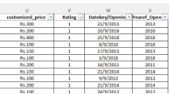

The inconsistent and missing values are Marked as not Available and missing values are Counted using COUNTBLANK () which is 9.

* Duplicate Values: No Duplicate Values in the data.
* Count(): Counted and replace the blank values to Not Available.
* Data Cleaning and validation: Changed the data type of each column. For data column
* No extra space or special characters to remove or trim.
* Also changed the Alignment and applied borders for cleaner look.
* There are not any inconsistent values.

**5. Use LOOKUP to fill countries using Country Code**

**Answer:** In original data Added New Column Country Name and applied the formula Vlookup using Array Formula to apply to all 9522 rows.

**Formula** =VLOOKUP (C2,'country description'!$A$1: $B$16,2,FALSE)

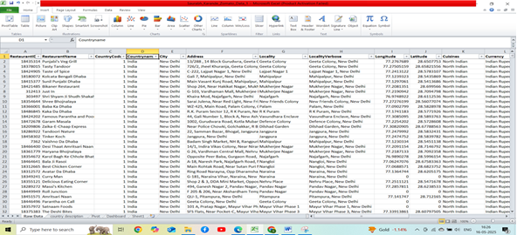

**6. Create a table of restaurants by country**

**Answer:** Use a **Pivot Table**:

* Rows: Country Name
* Values: RestaurantID (Count)

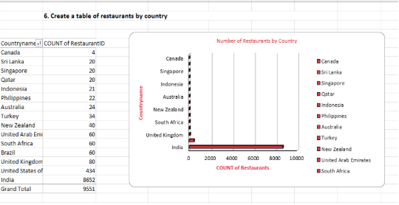

Using the Pivot Table, we can find out the number of restaurants in each country. And there are a total 9551 restaurants in different Countries.

Total (no. of Restaurants) The Maximum Number of restaurants are in India: 8652

The Minimum Number Of restaurants are in Canada: 4

**7. Also, the management wants to look at the number of restaurants open each year, so provide them with something here.**

**Answer:** In the above table there are number of restaurants opened in each year. Observing no of restaurants opened in every year there is increment in year 2011 but there is big drop in year 2012 and next 2 years there is good no of restaurants opened but again there is a drop in year 2015 and 2016 and there is good increment in year 2017 and 2018.

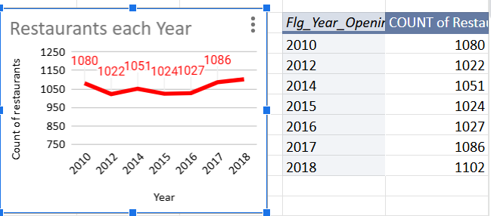

**8. What is the total number of restaurants in India in the price range of 4**?

**Answer:** The total number of restaurants in India in the price range of 4 is **388**.

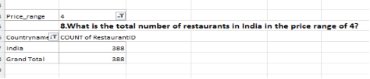

**9. What is the average number of voters for the restaurants in each country according to the data?**

**Answer:**

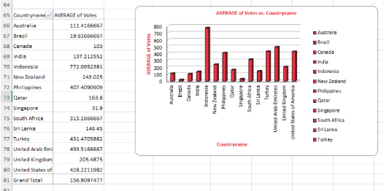

The average number of voters for the restaurants in each country according to the data is 156.91. The Highest Average of voters are in Indonesia where restaurants are 60. Followed by UAE & Turkey. The Lowest is in Brazil with 19.61 Average votes where and 60 restaurants. In spite of having Maximum number of Restaurants India has 137.21 Voters only.

**10. Calculate the average rating for all the restaurants that have price_range < 4**

**and provide online delivery. Use only the “IF” function, Logical Operators, and**

**Aggregation functions to solve this problem. [Note: Don’t use Conditional**

**aggregation in this question.**

**Answer:**

The formula is :=ArrayFormula(AVERAGE(IF(('Raw Data'!Q2:Q9552<4)*('Raw Data'!N2:N9552="Yes"), 'Raw Data'!T2:T9552)))

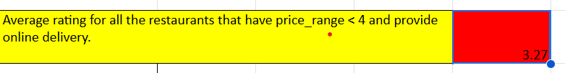

**11. Using Conditional formatting highlight the rows of restaurants that are located in the countries or cities that you’ve suggested to the management for opening new restaurants.**

**Answer:**

For this we have taken countries where number of restaurants is less than 60. So, there is clear opportunity to attract customers who wish to dine in new restaurants. Then applied Custom Formula rule in Conditional Formatting using following steps.

1.Select all data from sheet ‘Raw Data’

2.Click on Format

3.click on Conditional Formatting

4.add new rule

5.Format rule -> custom tule

6.add this formula : = IF(OR($D1="Turkey", $D1="Australia", $D1="Philippines", $D1="Indonesia", $D1="Sri Lanka", $D1="New Zealand", $D1="Singapore", $D1="Qatar", $D1="Canada"),TRUE,FALSE)

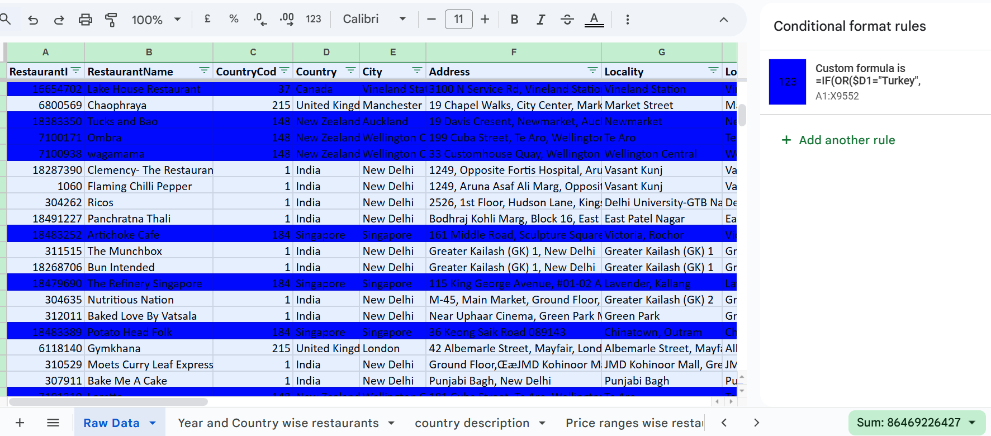

**12. Create a new customized price column that consists of the abbreviation/symbol of the currency along with the Average_cost_for_two value. [Use string operations to do this task]**

**Answer:** I use this formula for New Customized Price Column :

=CONCATENATE(MID(L2,FIND("(",L2)+1,FIND(")",L2)-FIND("(",L2)-1),"",S2)

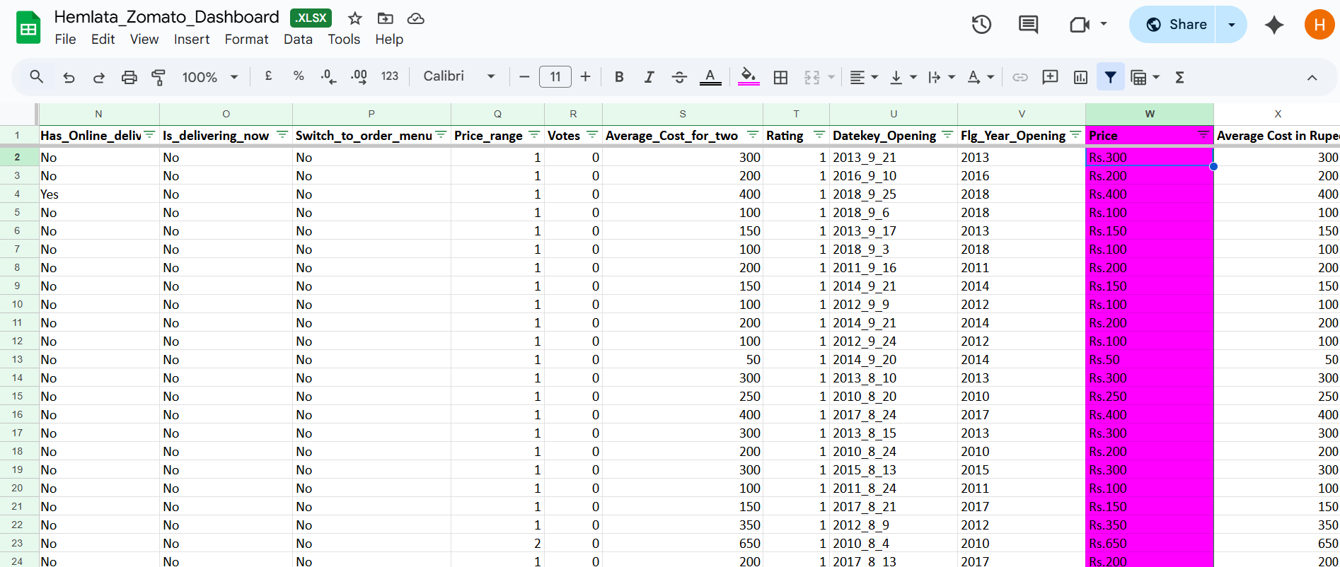

**13. How can you create an array formula in Excel or Google Sheets to count the number of restaurants listed that do not offer online delivery, are in the lowest price range, and have an average cost for two people less than or equal to 250 Indian Rupees?**

**Answer:**

* First found the conversion rate according to the currency in rupees.

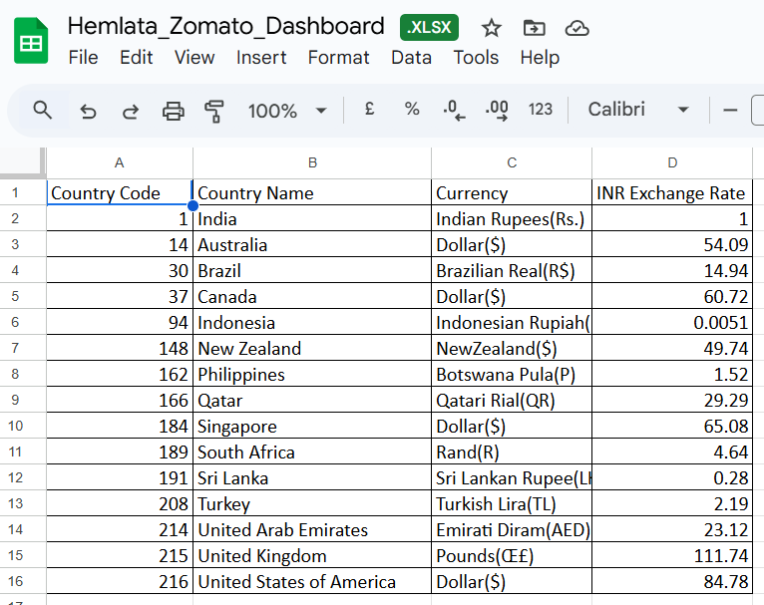

* Using VLOOKUP formula applied the conversion rate into new column average cost of 2 in rupees And multiplied it with the average cost of 2.

Formula used: **=S2*VLOOKUP($D2,'country description'!$B$2:$C$16,2,0).**

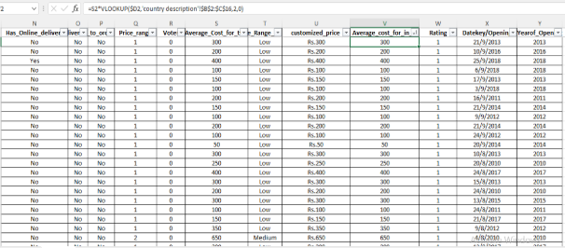

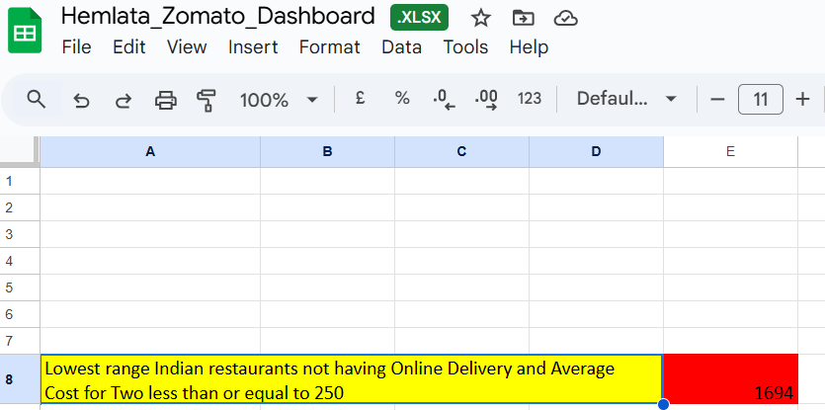

The number of restaurants listed that do not offer online delivery, are in the lowest price range, and have an average cost for two people less than or equal to 250 Indian Rupees is 1694. Formula: =Arrayformula(COUNT(IF(('Raw Data'!N$2:$N="No")*('Raw Data'!Q2:Q9552=1)*('Raw Data'!X2:X9552<=250),'Raw Data'!A2:A9552)))

**Subjective Question**

**1. Suggest a few countries where the team can open newer restaurants with lesser competition. Which visualization/technique will you use here to justify the suggestions?**

**Answer:**

As the chart indicates, these countries have a very low number of restaurants, while the average ratings remain high. This suggests that competition in these markets is relatively low, and there is a clear opportunity to attract customers who are willing to dine at new restaurants.

#### **Suggested Countries for New Restaurants (Low Competition):**

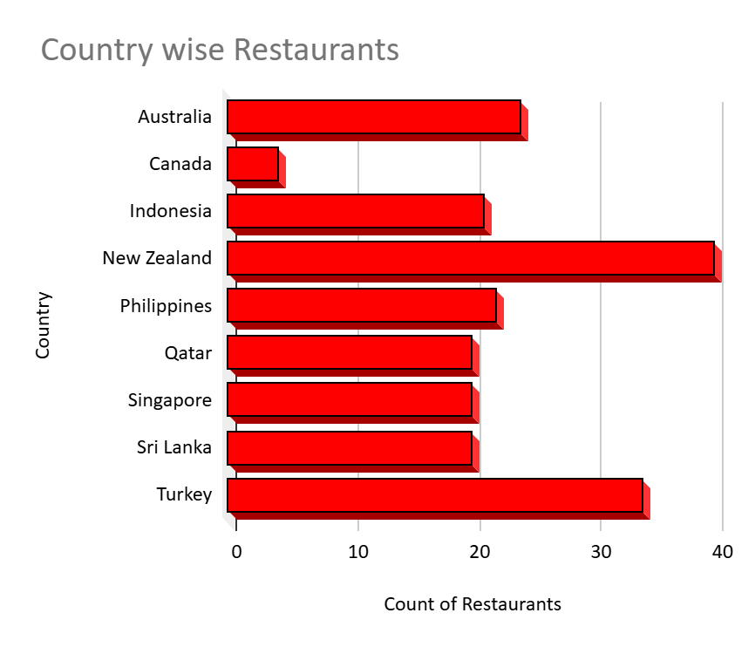

* **Canada** – 4 restaurants
* **Qatar** – 20 restaurants
* **Singapore** – 20 restaurants
* **Sri Lanka** – 20 restaurants
* **Indonesia** – 21 restaurants
* **Philippines** – 22 restaurants
* **Australia** – 24 restaurants
* **Turkey** – 34 restaurants
* **New Zealand** – 40 restaurants

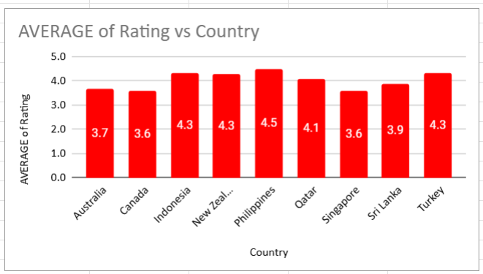

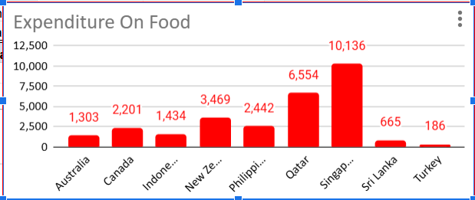

Additionally, the analysis of average cost for two persons reveals that prices are reasonable, indicating the potential for good market acceptance. Therefore, these countries offer a promising opportunity for opening new restaurants and expanding the business successfully.

#### **Conclusion:** Based on the data analysis of restaurant count, average rating, and cost for two persons, **countries such as Canada, Australia, Indonesia, Qatar, Philippines ,etc** emerge as ideal locations for new restaurant expansion. These countries exhibit low market saturation, favorable customer ratings, and affordable dining costs, which collectively present a strong potential for successful market entry and business growth.

**2. Come up with the names of States and cities in the suggested countries suitable for opening restaurants.**

**Answer:**

Identify the most suitable states and cities in the recommended countries where new restaurants can be opened, based on low competition, favorable customer ratings, and reasonable costs.

**Techniques Used:**

* Pivot Table Analysis to summarize the number of restaurants, average rating, and average cost for two persons.
* Bar-Line Combo Chart to visualize restaurant distribution, cost, and ratings city-wise.

Shape

**Suggested Countries with Best Cities for Expansion:**

|  |  |  |
| --- | --- | --- |
| Country | Suggested Cities | Reason for Selection |
| Canada | Vineland Station | High cost for two (₹4398), only 1 restaurant, high rating (4.3) — premium opportunity. |
|  | Chatham-Kent, Consort, Yorkton | Only 1 restaurant each, low competition, moderate cost (₹1571). |
| Indonesia | Tangerang | Low cost (₹1310), high rating (4.3), only 2 restaurants — growth potential. |
|  | Bandung, Bogor | Only 1–2 restaurants, high ratings (4.2–3.9), low cost (₹786–₹838). |
| Australia | (Country-wide analysis) | Overall low saturation (24 restaurants), average rating 3.7 — room for expansion. |
| Turkey | Ankara, Istanbul | Moderate restaurant count (14–20), high ratings (4.3), very low cost (₹178–₹190). |
| Qatar | Doha | Single main city, high average cost (₹5189) — premium segment potential. |
| Philippines | Manila (implied) | Low saturation (22 restaurants), high rating (4.5), affordable cost (₹2475). |
| Sri Lanka | Colombo | Low restaurant count (20), low cost (₹665), decent rating (3.9). |
| New Zealand | Auckland, Wellington City | Low restaurant count, average rating (4.3), moderate cost (₹3483). |
| Singapore | Singapore (single city) | Expensive (₹10318), single city opportunity — suitable for high-end dining segment. |

Shape

**Conclusion:**

Based on the city-wise data analysis, the best cities for opening new restaurants include:

* **Vineland Station (Canada)**
* **Tangerang (Indonesia)**
* **Ankara and Istanbul (Turkey)**

These cities exhibit high average ratings, very low competition, and favorable cost structures. Other promising locations include **Doha (Qatar)** and **Auckland/Wellington City (New Zealand)** for potential expansion into premium or mid-range markets. These cities provide clear opportunities for establishing a successful restaurant business due to their underdeveloped competition and customer affordability.

Shape

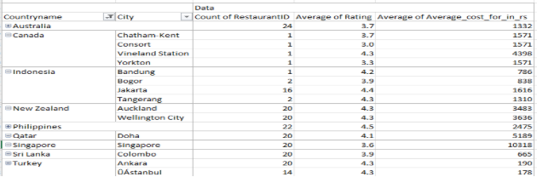

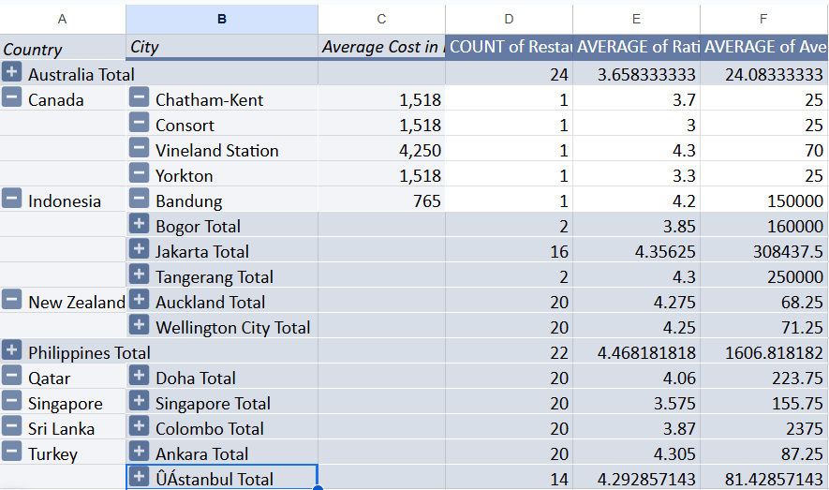

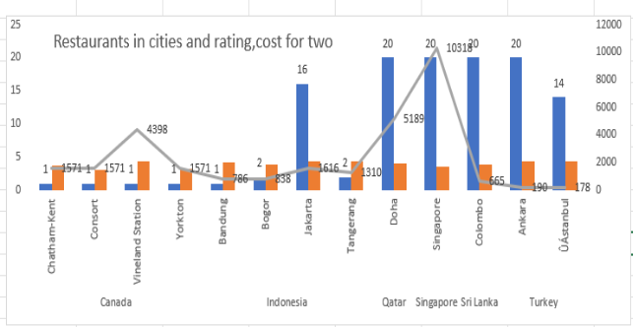

3**. According to the countries you suggested, what is the current quality regarding ratings for restaurants that are open there?**

**Answer:** The restaurant ratings in the suggested countries indicate a generally good quality of service. Countries like the Philippines (4.26), Turkey (4.16), and New Zealand (4.16) have the highest average ratings, suggesting strong customer satisfaction and well-performing restaurants. Indonesia (4.05) and Qatar (3.98) also reflect good restaurant quality.

Meanwhile, Sri Lanka (3.82), Australia (3.62), Singapore (3.58), and Canada (3.58) show moderate ratings, highlighting opportunities to improve food service quality and customer experience.

Overall, most recommended countries have favorable ratings, making them suitable for new restaurant ventures.

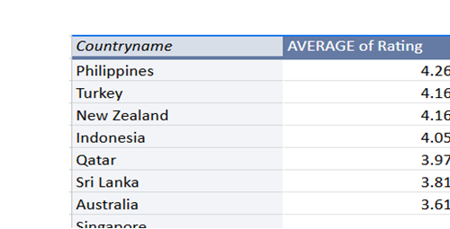

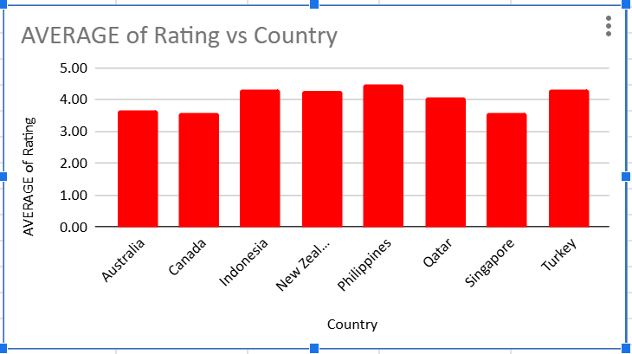

**4. Also, what is the current expenditure on food in the suggested countries, so we can keep our financial expenditure in control?**

**Answer:** To understand the food expenditure patterns in the recommended countries to help control financial expenditure.

Shape

Findings: Current Expenditure on Food:

|  |  |  |  |  |  |
| --- | --- | --- | --- | --- | --- |
| Country | Price Range 1 (₹) | Price Range 2 (₹) | Price Range 3 (₹) | Price Range 4 (₹) | Remark |
| New Zealand | 1191 | 1977 | 2732 | 5278 | Moderate expenditure across ranges. |
| Australia | 387 | 1106 | 1659 | 6636 | Higher spending at premium range 4. |
| Sri Lanka | 355 | 355 | 697 | 1167 | Very affordable across all ranges. |
| Canada | 1571 | 0 | 0 | 4398 | Expensive mainly at price range 4. |
| Singapore | 0 | 1325 | 2783 | 13652 | Extremely high at premium (range 4). |
| Qatar | 0 | 1160 | 1994 | 6617 | Premium category costly. |
| Turkey | 94 | 174 | 423 | 0 | Very low-cost market. |
| Indonesia | 367 | 1529 | 0 | 0 | Affordable in low to mid ranges. |
| Philippines | 924 | 1469 | 3987 | 0 | Balanced, suitable for mid-market. |

Shape

Insights:

1. Low-Cost Markets: Turkey, Sri Lanka, Indonesia – Best for budget-friendly restaurants, very low expenditure even in mid ranges.
2. Mid-Range Markets: New Zealand, Philippines – Moderate cost in ranges 2 & 3; suitable for casual dining.
3. High-Cost/Premium Markets: Canada, Singapore, Qatar, Australia – Expensive especially in price range 4; focus on premium service offerings required.

Shape

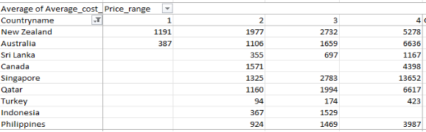

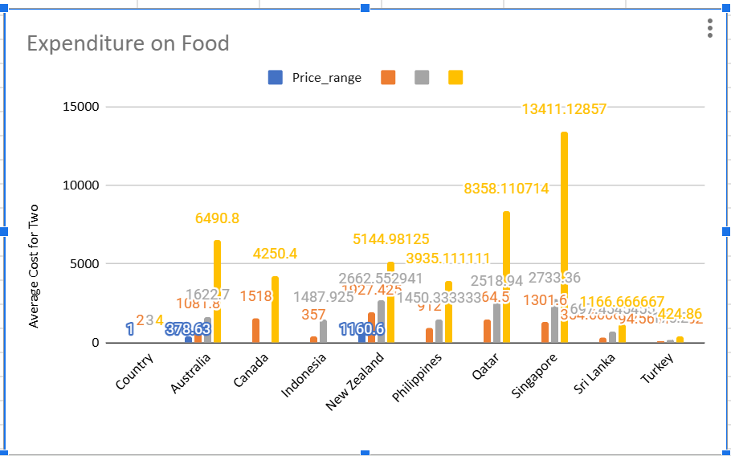

**Conclusion:**

To maintain financial control, countries such as Sri Lanka, Turkey, and Indonesia are ideal for budget-friendly restaurant setups due to their low average food costs. For mid-range offerings, New Zealand and Philippines present a balanced expenditure. However, in countries like Canada, Singapore, Qatar, and Australia, where costs for premium dining are high, a careful pricing strategy and premium service offerings are recommended to ensure profitability without exceeding operational costs.

**5. Come up with the names of restaurants from the recommended states that are our biggest competitors and also those that are rated in the lower brackets, i.e. 1-2 or 2-3.**

**Answer:**

Top Competitor Restaurants (Rating ≥ 4.5)

These restaurants are highly rated (4.5–4.9) in the recommended countries and are strong competitors: These restaurants are highly rated (close to 5) and operate in countries we are targeting. They represent strong competition due to their high customer satisfaction and likely popularity in the local market**.**

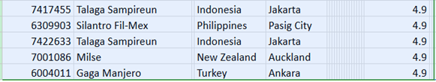

#### **Lowest Rated Restaurants (Rating <3)**

#### **These restaurants received the lowest ratings, indicating poor customer feedback:**

These restaurants have **poor ratings**, indicating potential problems like low quality, bad service, or poor customer satisfaction. They show what **not** to do and may present an opportunity for market entry with better quality.

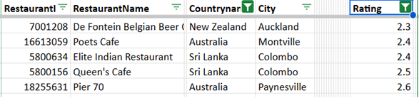

**6. Which cuisines should we focus on in the newer restaurants to get better feedback? Does the choice of cuisines affect the restaurant ratings?**

**Answer**: To determine which cuisines to focus on in newer restaurants to receive better customer feedback and understand if the choice of cuisine significantly affects restaurant ratings.

Findings: Recommended Cuisines by Country:

|  |  |  |
| --- | --- | --- |
| Country | Cuisines Recommended | Average Rating |
| Australia | Pizza, Bar Food | 4.6 |
| Indonesia | Sushi, Japanese; Sunda, Indonesian; Asian, Indonesian | 4.9 |
|  | Desserts, Bakery; Cafe, Italian, Coffee | 4.6 |
| New Zealand | Desserts; Seafood, Kiwi; European; Ice Cream, Dessert | 4.7 – 4.9 |
| Philippines | Japanese, Sushi; European, Asian; Filipino, Mexican | 4.85 – 4.9 |
|  | French, Japanese; Japanese, Korean; Filipino | 4.7 – 4.9 |
| Qatar | Seafood, American; Chinese; Indian | 4.65 – 4.9 |
| Sri Lanka | Seafood | 4.9 |
| Turkey | Cafe; World Cuisine | 4.9 |

Shape

**Insights:**

1. Cuisines with Highest Ratings:
   * Japanese, Sushi, Sunda, Indonesian, and World Cuisine consistently received 4.9 ratings, indicating strong customer preference.
2. Multi-Cuisine Popularity:
   * Countries like Philippines, Indonesia, and Qatar favor a blend of Asian and Western cuisines, suggesting new restaurants should offer variety.
3. Local Cuisine Importance:
   * Localized cuisines such as Sunda (Indonesia) and Seafood (Sri Lanka) show high ratings, highlighting the value of including regional dishes.

Shape

**Conclusion:**

Yes, the choice of cuisine directly affects restaurant ratings. To receive better customer feedback in new outlets, focus should be given to:

* Japanese, Sushi, Indonesian, and World Cuisine for universal appeal.
* Local popular cuisines such as Seafood in Sri Lanka and Sunda cuisine in Indonesia.
* A mix of Asian and Western cuisines in diverse markets like the Philippines and Qatar.

This strategy will help attract a wider customer base and improve overall restaurant ratings.

Shape

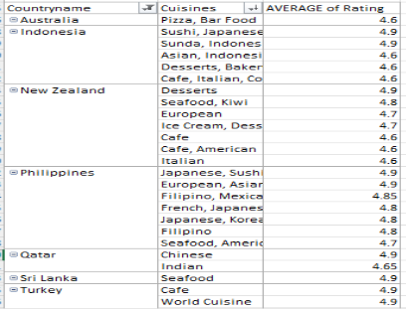

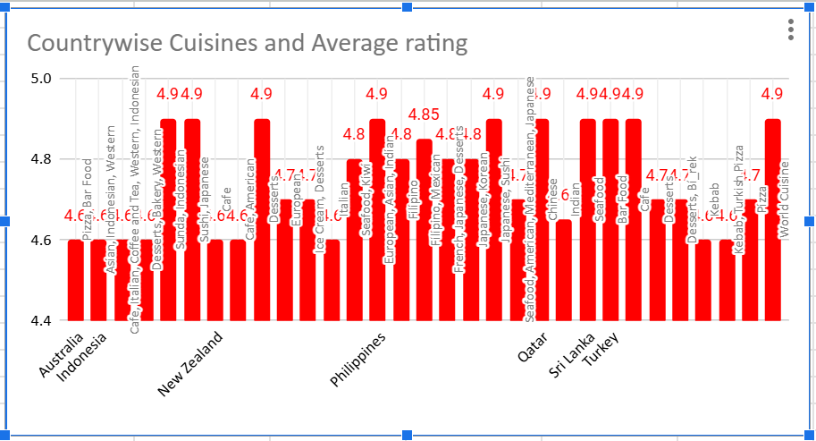

**7. According to our current data, should we go for online delivery and table booking? Does that affect the customer’s ratings?**

**Answer:** Yes, based on trends observed in restaurant data globally, both **online delivery** and **table booking options** can **positively impact customer ratings**

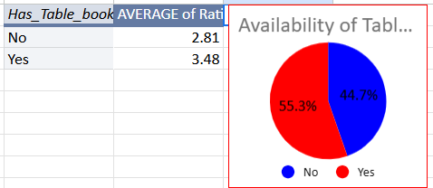

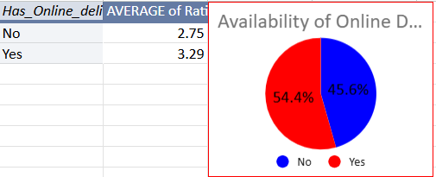

**Conclusion:**

**Yes**, you **should offer both**:

* **Online delivery** is a must in modern dining, especially post-pandemic.
* **Table booking** adds a layer of professionalism and convenience for dine-in.

Together, they **enhance overall customer experience**, leading to **better ratings and repeat business**.

**8. Should the team keep the rate of cuisines higher? Will that affect the feedback? According to our data are the rates of cuisines and ratings correlated?**

**Answer:**

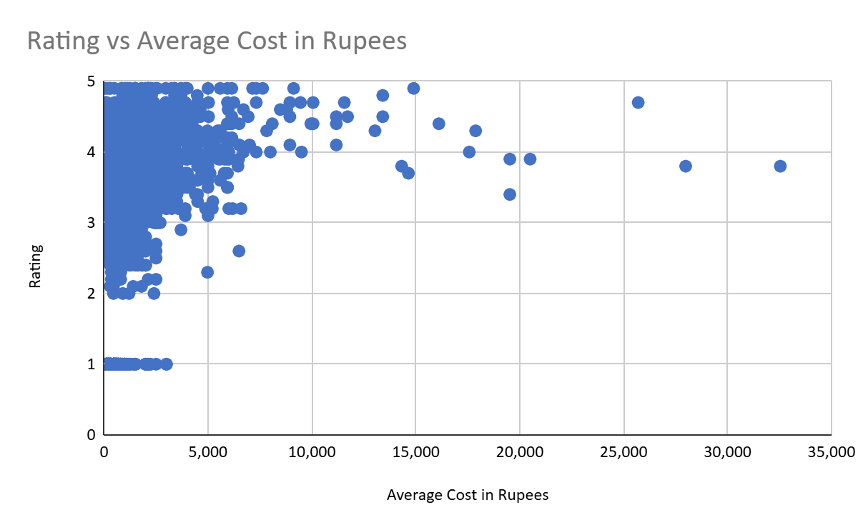

**(Refer to sheet Corre of Cuisines Cost & Rating for above graph)**

**Approach** –

I have created scattered chart by considering average rating of cuisines and their prices to understand whether there is any correlation between them

**Insights**-

The rates of cuisines and ratings are moderately correlated, increasing cuisine rates doesn’t guarantee better feedback or ratings because customers are giving ratings 3 for low cost cuisines also.

### **Q.9 Distribution of the number of restaurants of different price ranges in all countries**

**Answer:**

* Low-priced (Price range 1) restaurants dominate across most countries, especially India, which has the highest count (4295).
* Medium-priced (Price Range 2) restaurants are significant in countries like India and United States, though less common overall.
* High-priced (Price Range 3) restaurants are concentrated in India (1111) and USA (110), while many countries have very few or none.
* Premium restaurants (Price Range 4) are rare overall, with small presence in India, Philippines, and a few others.
* Countries like Sri Lanka and South Africa show more balanced distributions, while others like Australia, Brazil, and Turkey have only low or medium price segments.

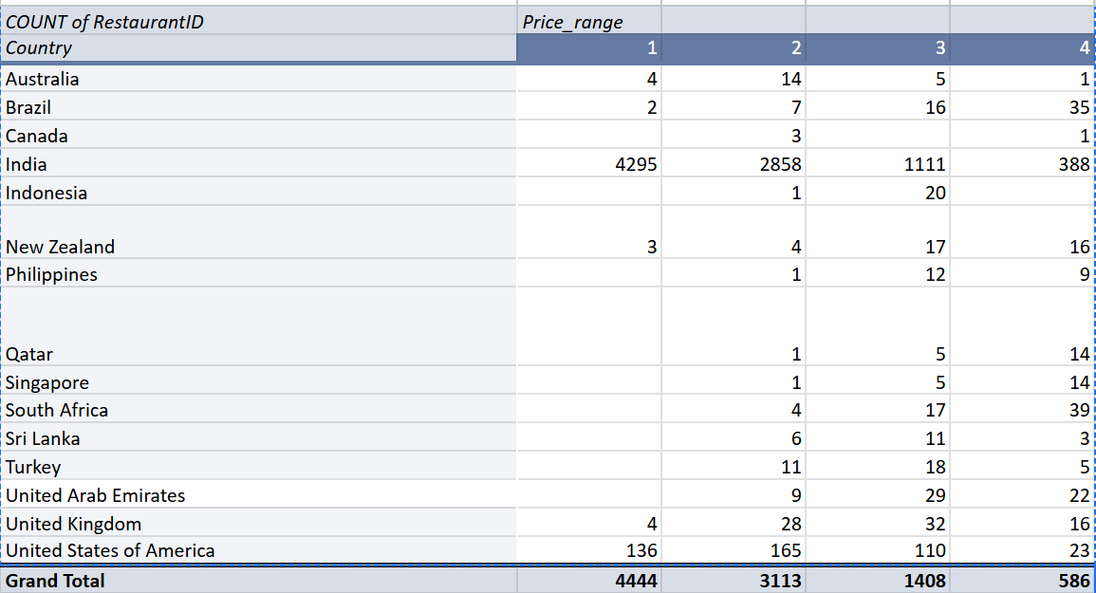

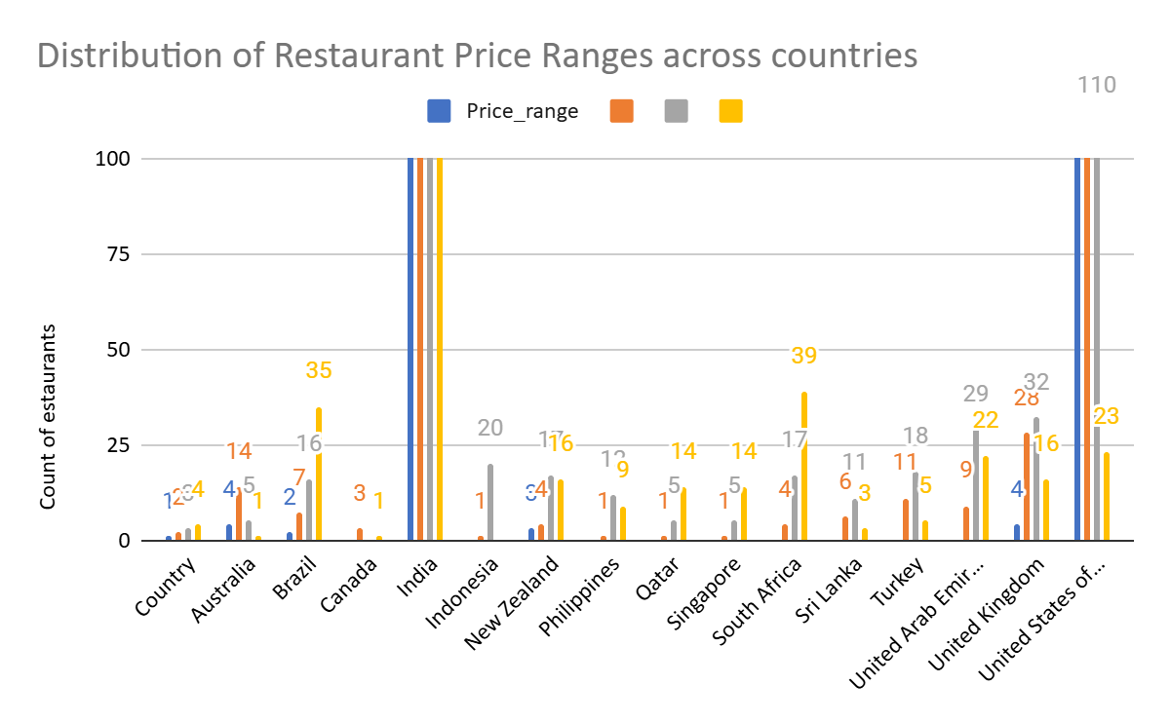

**Conclusion:**  
 **The global restaurant market, especially in developing countries, is skewed toward affordable dining, with high-end options limited to a few regions.**

**10. Explain your approach in brief for suggesting countries/cities in order to open new restaurants, if the objective and subjective questions have not been given to assist you. [you must give bullet pointers to answer this question.]**

**Answer:**

**Start with Understanding the Data**

* Explore the dataset to know what information is available (e.g., countries, cities, ratings, cuisine types).
* Identify key columns that can help in location analysis.

**Clean and Organize the Data**

* Handle missing entries and standardize inconsistent formats.
* Use formulas (like VLOOKUP) to match codes with country names.

**Check Restaurant Presence**

* Use pivot tables or charts to summarize the number of restaurants in each country.
* Look for areas with fewer existing restaurants — these may have less market competition.

**Review Quality Indicators**

* Calculate the average ratings for restaurants in each location.
* Give preference to regions with good customer feedback but lower restaurant density.

**Analyze Cost Trends**

* Observe the food cost levels in different countries (based on available currency/cost data).
* Target areas with moderate spending — enough to support dining out, but not overly expensive.

**Understand Cuisine Preferences**

* Find out which cuisines are rated highly overall.
* Match this with locations where those cuisines are not yet saturated**.**

**Combine Key Metrics**

* Use a scoring or filtering method to shortlist cities that meet all major criteria:  
  + Low competition
  + Good ratings
  + Viable food cost levels